LineageIQ — Comprehensive Deterministic Parsing and Cross-Language Lineage Design

1. Executive summary
LineageIQ should support automated lineage discovery from enterprise application repositories containing SQL, C#, .NET configuration files, stored procedure references, and dynamically constructed SQL — without relying on AI or LLMs for parsing or lineage determination.
The recommended solution is a deterministic, multi-language static analysis platform that combines language-specific AST parsers, compiler-based semantic analysis, symbolic data-flow tracking, cross-file and cross-repository resolution, and a canonical lineage graph.
The key architectural principle is:
Parse once, extract structured facts, resolve dependencies, prove data flows, and publish evidence-backed lineage.
This design separates five concerns:
- Repository discovery: Identify source files, projects, configuration, dependencies, and database interactions.
- Language-specific parsing: Parse SQL with a dialect-aware parser and C# with Roslyn.
- Program analysis: Resolve method calls, variable assignments, SQL construction, and execution paths.
- Lineage resolution: Establish source-to-target data dependencies at table and column levels.
- Graph publication: Normalize results into the LineageIQ canonical model and publish to Neo4j and other metadata platforms.

Target outcomes
Capability | Design target
Static SQL lineage | Table and column level
Embedded SQL in .NET | Extract and correlate
SQL files called from C# | Resolve file-to-execution relationship
Dynamic SQL | Resolve constants and bounded symbolic expressions
Cross-method SQL execution | Interprocedural analysis
Stored procedures | Link invocations to procedure definitions
Entity Framework / LINQ | Supported through specialized adapters
Cross-repository lineage | Global symbol and asset resolution
Data quality rules | Extract supported SQL and C# validation patterns
Auditability | Source locations, evidence, parser version, resolution status
Incremental processing | Recompute impacted facts and lineage after Git changes
The platform should not claim complete lineage where runtime information, schema metadata, or source code is unavailable.

2. Reference architecture
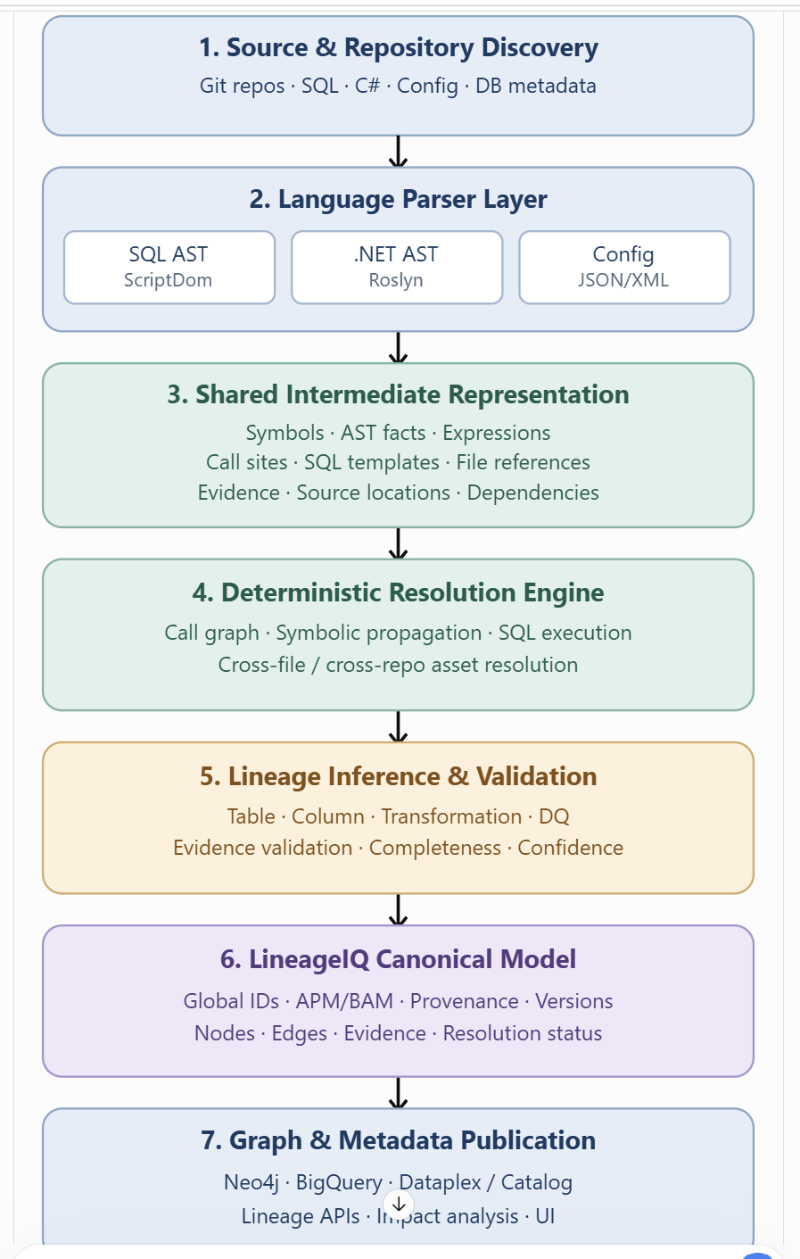

The parser layer must not publish final lineage directly. Each parser produces deterministic facts that downstream services can independently validate and correlate.

3. Detailed component design
3.1 Repository discovery service
The repository discovery service scans a Git commit snapshot and creates an inventory of all relevant artifacts.
Inputs: Git repository URL, commit SHA, application identifier, parser policy, optional database metadata, and configuration profiles.
Outputs: File inventory, project dependency graph, language classification, and parsing work queue.
Example inventory:
Artifact | Classification | Processing
SQL/extract_customers.sql | T-SQL | SQL parser
Services/CustomerService.cs | C# | Roslyn
Repositories/CustomerRepository.cs | C# | Roslyn
appsettings.json | Configuration | JSON parser
CustomerRisk.csproj | Project definition | MSBuild evaluation
CustomerModel.cs | C# model | Roslyn symbol indexing
Procedures/sp_load_risk.sql | Stored procedure | SQL parser
The discovery service should also resolve .sln and .csproj dependencies, NuGet references, linked files, generated code, and embedded resources.
Important: Build a complete project-level semantic context whenever possible. Parsing a .cs file in isolation can identify syntax but may not resolve overloaded methods, external symbols, or extension methods correctly.
3.2 SQL parser service
For SQL Server, use Microsoft ScriptDom with dialect/version configuration.
Its responsibility is to convert SQL AST nodes into normalized facts:
SQL construct | Extracted facts
SELECT | Sources, projections, predicates, expressions
INSERT ... SELECT | Targets, sources, column mappings
UPDATE | Target assignments, predicates, source dependencies
MERGE | Matched/unmatched branches, insert/update/delete
CREATE VIEW | View definition and underlying dependencies
Stored procedure | Parameters, statements, dynamic SQL, called procedures
EXEC | Procedure or dynamic execution reference
CASE, CAST, functions | Expression-level derivation
JOIN | Join predicates and participating sources
WHERE, HAVING | Row-selection dependencies
GROUP BY | Grouping dependencies
SELECT * | Deferred schema-based expansion
For multi-dialect SQL, use a parser adapter for each supported dialect rather than assuming T-SQL AST semantics apply to BigQuery, Hive, Oracle, or Teradata.
3.3 .NET parser service
Roslyn should operate in two passes.
Pass A — Syntax indexing
Extract namespaces, classes, methods, fields, variables, string expressions, invocations, and source locations.
Pass B — Semantic and data-flow analysis
Resolve symbols, method targets, overloads, assignments, return values, parameters, and supported SQL execution sinks.
A simplified Roslyn extraction example:

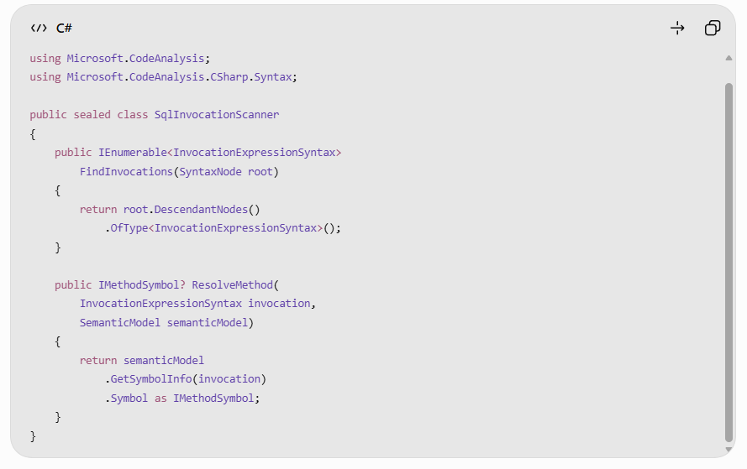

This code identifies invocations and their resolved method symbols. It is a building block, not a complete SQL execution detector.
LineageIQ should classify a call as a database execution sink only when its resolved symbol matches a supported API contract or a configured application-specific wrapper.
For example:
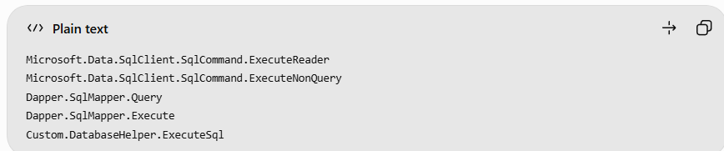

For ADO.NET, the resolver must also track the command object's CommandText, CommandType, connection, and eventual execution call. An invocation name alone is insufficient.
3.4 Shared intermediate representation
I recommend two separate data contracts:
- Parser IR: Low-level facts about code, expressions, SQL statements, and references.
- LineageIQ canonical graph: Normalized assets, relationships, lineage evidence, and business metadata.
This prevents language-specific parsing details from leaking into your enterprise lineage model.
An example Parser IR fact:

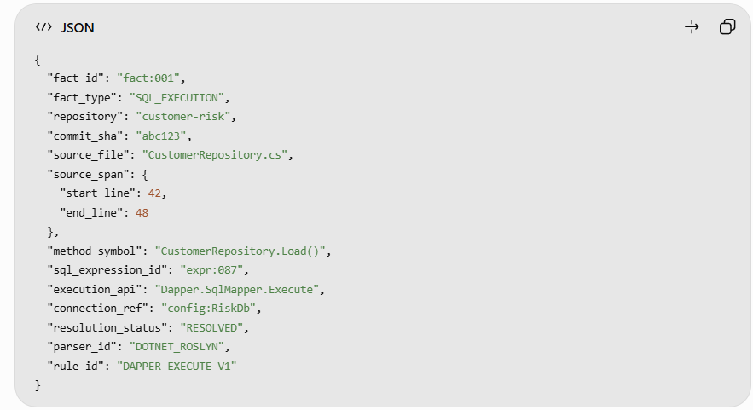

Every fact should carry a reproducible identifier, parser version, source location, commit SHA, and evidence reference.

4. Complete working example: SQL and .NET in one repository
Consider this application:
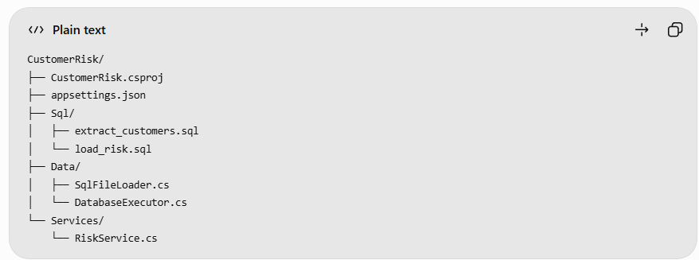

4.1 Source SQL
Sql/extract_customers.sql
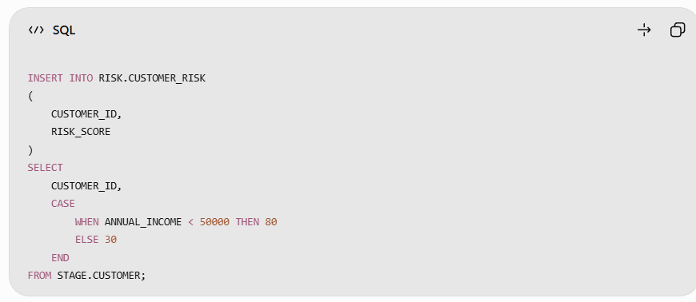

4.2 .NET execution logic
Data/SqlFileLoader.cs
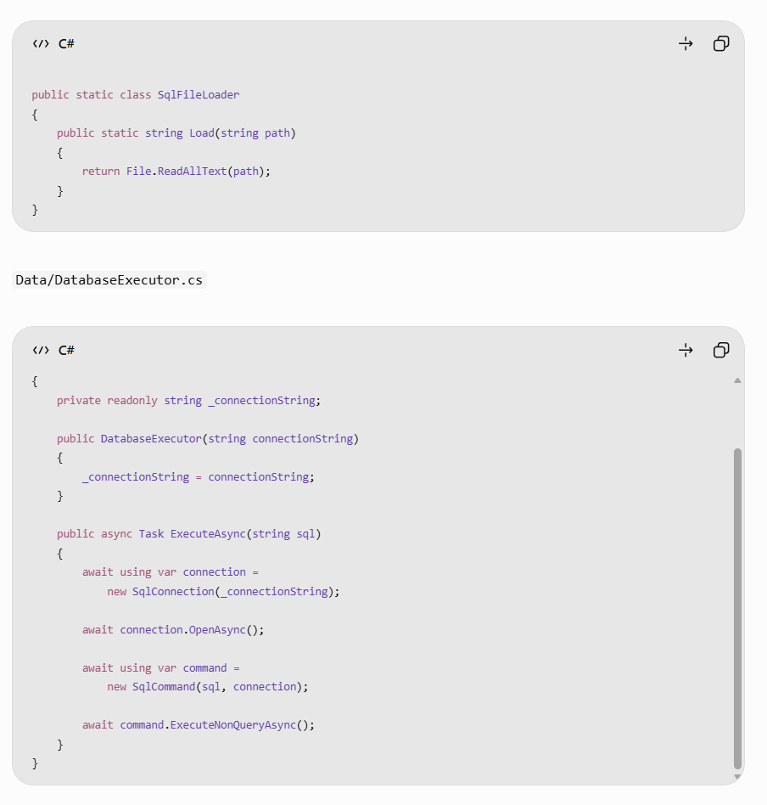
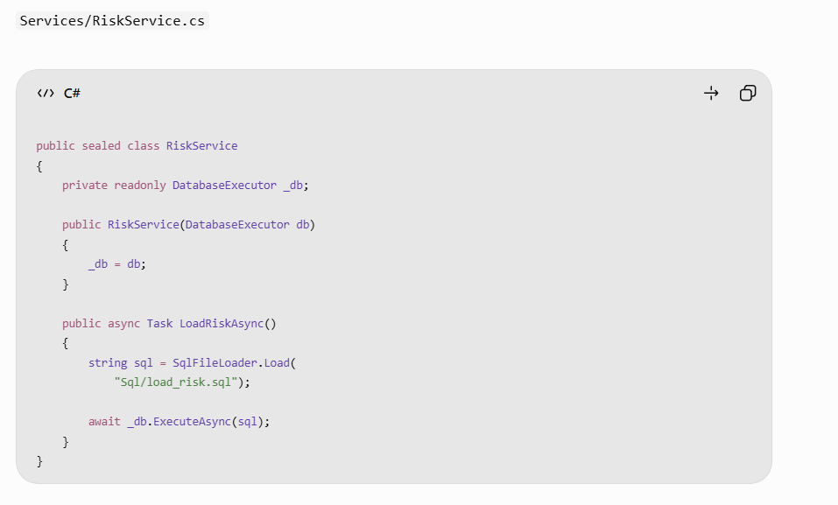
4.3 Deterministic analysis sequence
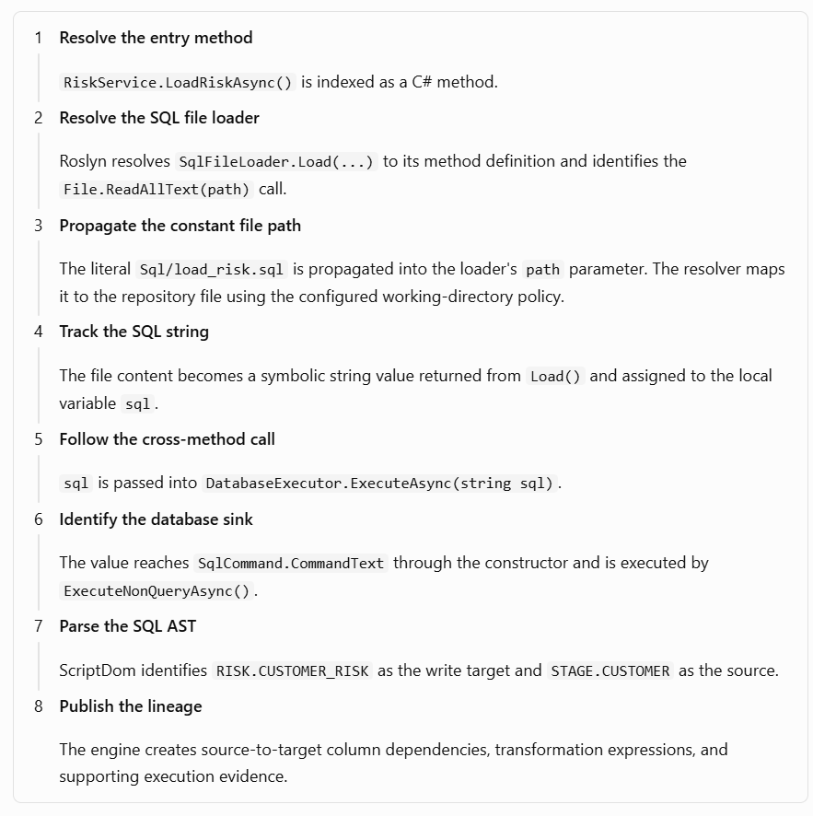

4.4 Resulting lineage graph

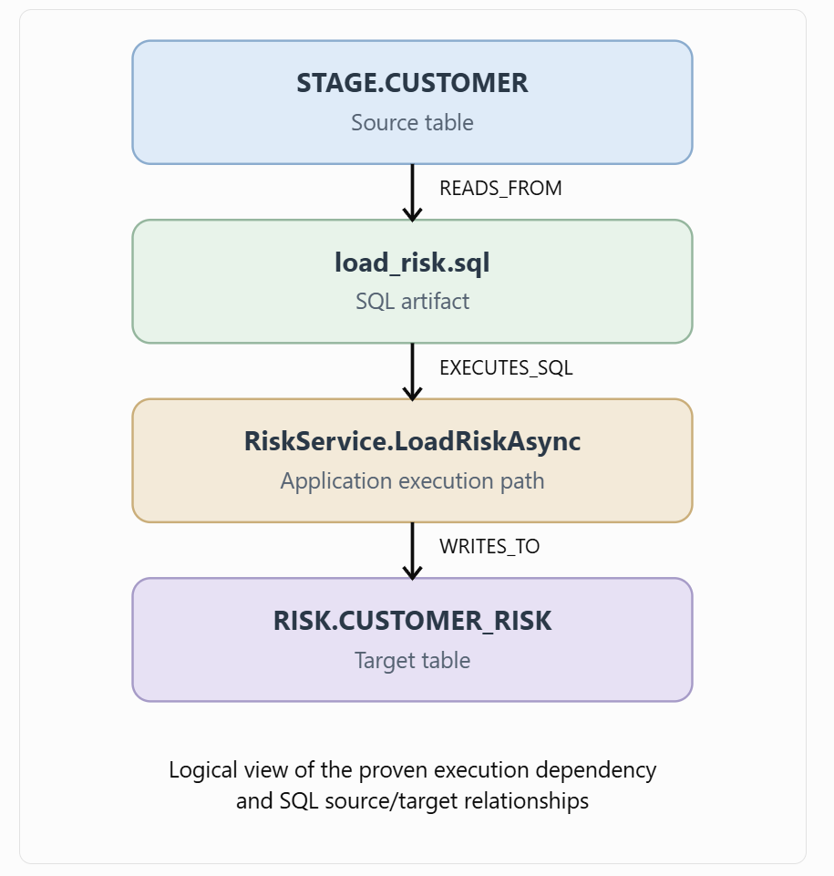

The graph above is a simplified visualization. In Neo4j, the actual model should preserve SQL statements, code methods, and execution calls as distinct nodes or evidence records.

4.5 Column-level lineage
The SQL parser produces:
Target column | Source column | Transformation
RISK.CUSTOMER_RISK.CUSTOMER_ID | STAGE.CUSTOMER.CUSTOMER_ID | Direct mapping
RISK.CUSTOMER_RISK.RISK_SCORE | STAGE.CUSTOMER.ANNUAL_INCOME | CASE expression
The CASE expression is:

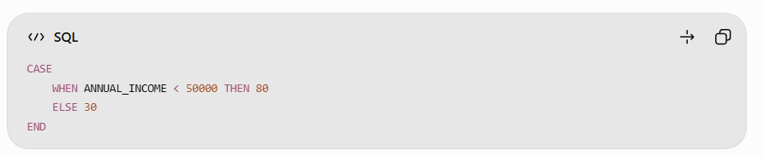

The canonical graph should retain both the source dependency and the exact transformation expression.
Important limitation: This example proves lineage from STAGE.CUSTOMER to RISK.CUSTOMER_RISK. The presence of extract_customers.sql elsewhere in the repository does not prove that it populates STAGE.CUSTOMER. That upstream edge should only be added when a separate load operation, mapping, or other evidence establishes the connection.

5. Cross-method and cross-file symbolic resolution
A key LineageIQ capability is following SQL values across method boundaries.
Consider:
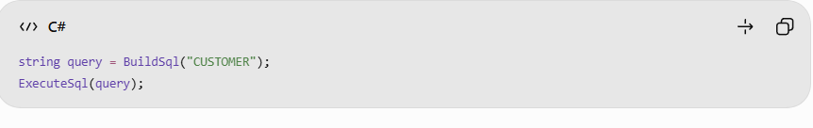
The resolver should create a symbolic value-flow graph:
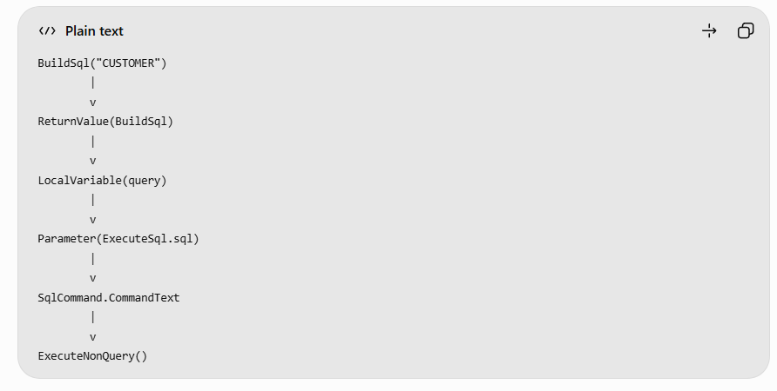
5.1 Symbolic value representation
Instead of representing every string as plain text, use a small expression algebra:
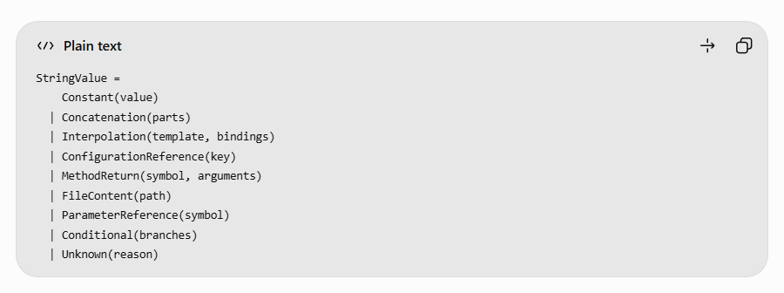
Examples:
C# expression | Symbolic representation
"SELECT * FROM CRM.CUSTOMER" | Constant(...)
"CRM." + "CUSTOMER" | Constant("CRM.CUSTOMER") after folding
$"CRM.{table}" | Interpolation(...)
configuration["SourceTable"] | ConfigurationReference(...)
File.ReadAllText(path) | FileContent(path)
BuildQuery(region) | MethodReturn(...)

5.2 Resolution algorithm

def resolve_value(expr, context, depth=0):
if depth > context.max_depth:
return Unknown("DEPTH_LIMIT")

if expr.kind == "CONSTANT":
return Constant(expr.value)

if expr.kind == "CONCAT":
parts = [
resolve_value(p, context, depth + 1)
for p in expr.parts
]
return simplify_concat(parts)

if expr.kind == "CONFIG_REF":
return context.resolve_config(expr.key)

if expr.kind == "FILE_READ":
path = resolve_value(
expr.path, context, depth + 1
)
return context.resolve_file_content(path)

if expr.kind == "METHOD_CALL":
summary = context.get_method_summary(
expr.method_symbol
)
return summary.evaluate(
expr.arguments, context, depth + 1
)

return Unknown("UNSUPPORTED_EXPRESSION")

This is conceptual pseudocode. A production implementation needs cycle detection, control-flow joins, branch-sensitive evaluation, recursion handling, and explicit limits on the number and size of possible values.
5.3 Interprocedural method summaries
For scalability, do not repeatedly analyze the same method body for every call.
Generate a reusable method summary:
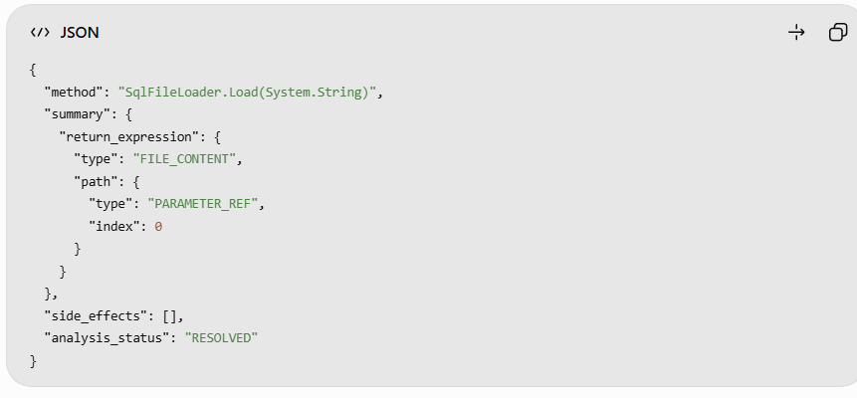

This allows LineageIQ to evaluate SqlFileLoader.Load("Sql/load_risk.sql") without reprocessing the full method body.
Method summaries should be invalidated when the method implementation or relevant dependencies change.

6. Dynamic SQL resolution design
Dynamic SQL must be handled conservatively.
Consider:
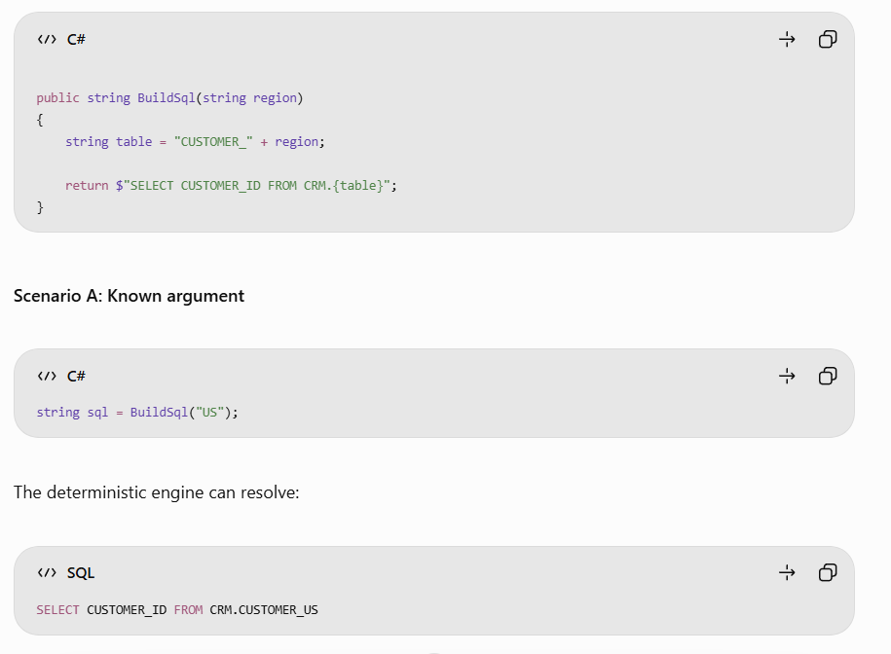

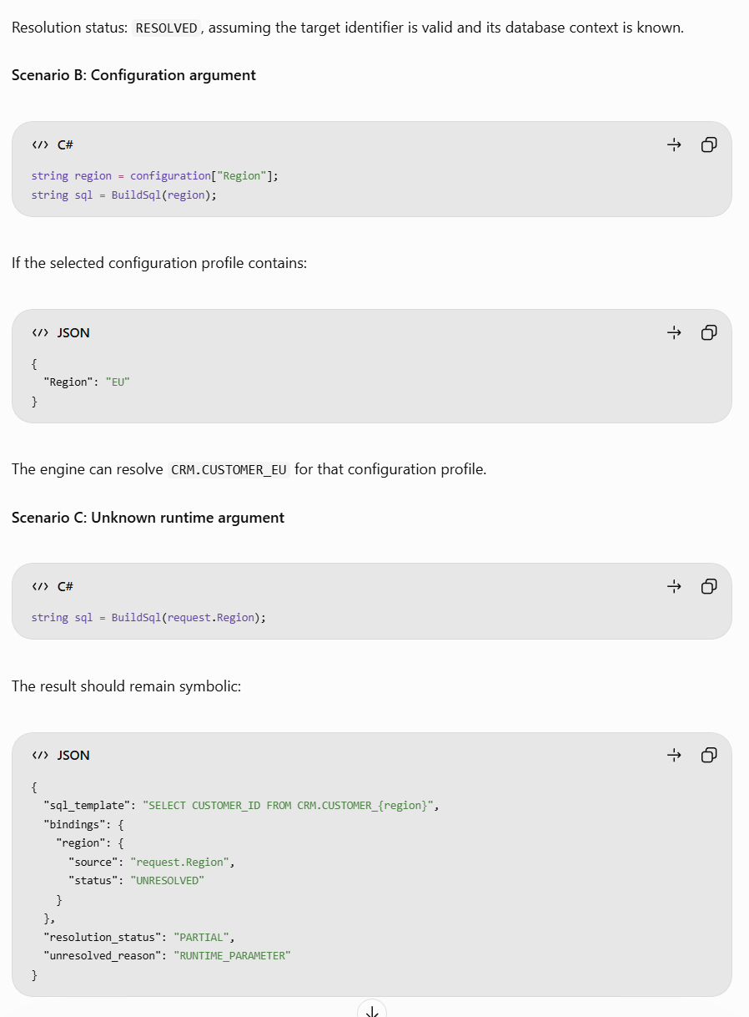

Do not create a confirmed lineage edge to a guessed table.
Dynamic SQL resolution hierarchy
1
Compile-time constants
Literal strings, constant folding, interpolated constants
2
Local static analysis
Assignments, branches, and local variable propagation
3
Interprocedural analysis
Method arguments, return values, and call chains
4
Configuration resolution
Selected environment profiles, appsettings, mapped secrets metadata
5
Metadata-assisted resolution
Known schemas, table definitions, stored procedure definitions
6
Runtime evidence enrichment
Approved query logs or traces for otherwise unresolved SQL
Runtime evidence is optional enrichment and should be identified separately from static-analysis evidence. It does not make an otherwise unproven static code path deterministic.

7. SQL execution framework adapters
Enterprise .NET repositories use different database access patterns. LineageIQ should support these through an extensible execution sink adapter registry.
Framework | Detection mechanism | Additional analysis
ADO.NET | SqlCommand, DbCommand | CommandText, connection, command type
Dapper | Query, Execute, QueryAsync | SQL argument and parameter bindings
Entity Framework Core | FromSql, ExecuteSqlRaw, LINQ | ORM model and provider mappings
Stored procedures | CommandType.StoredProcedure | Procedure name and parameters
Custom database wrappers | Configured method symbols | Wrapper summaries and argument mapping
Reflection-based frameworks | Static call and metadata analysis | Potentially unresolved runtime behavior

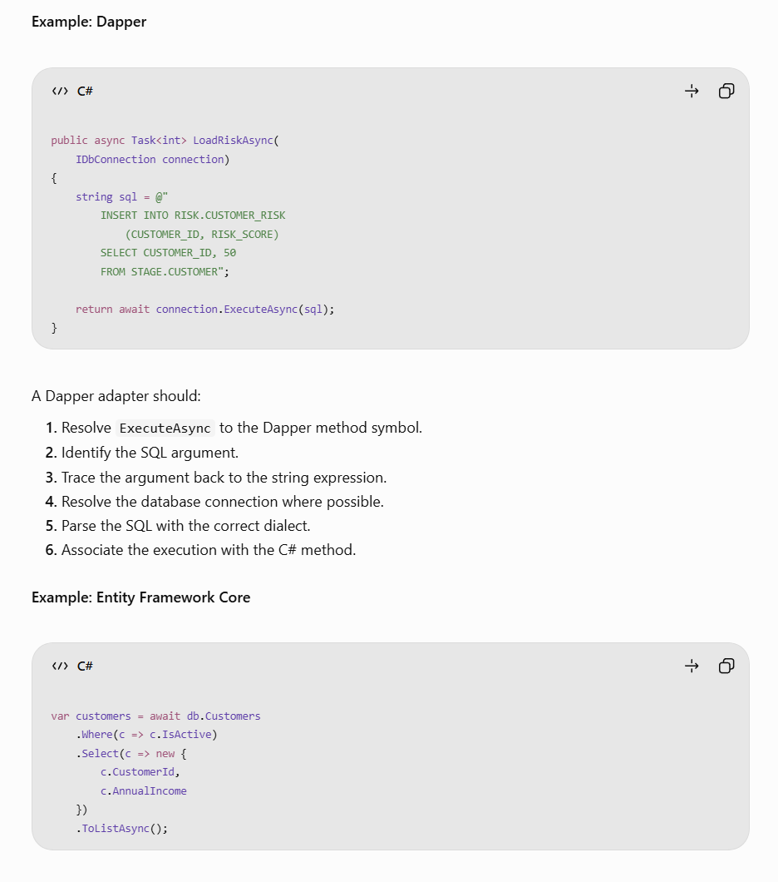
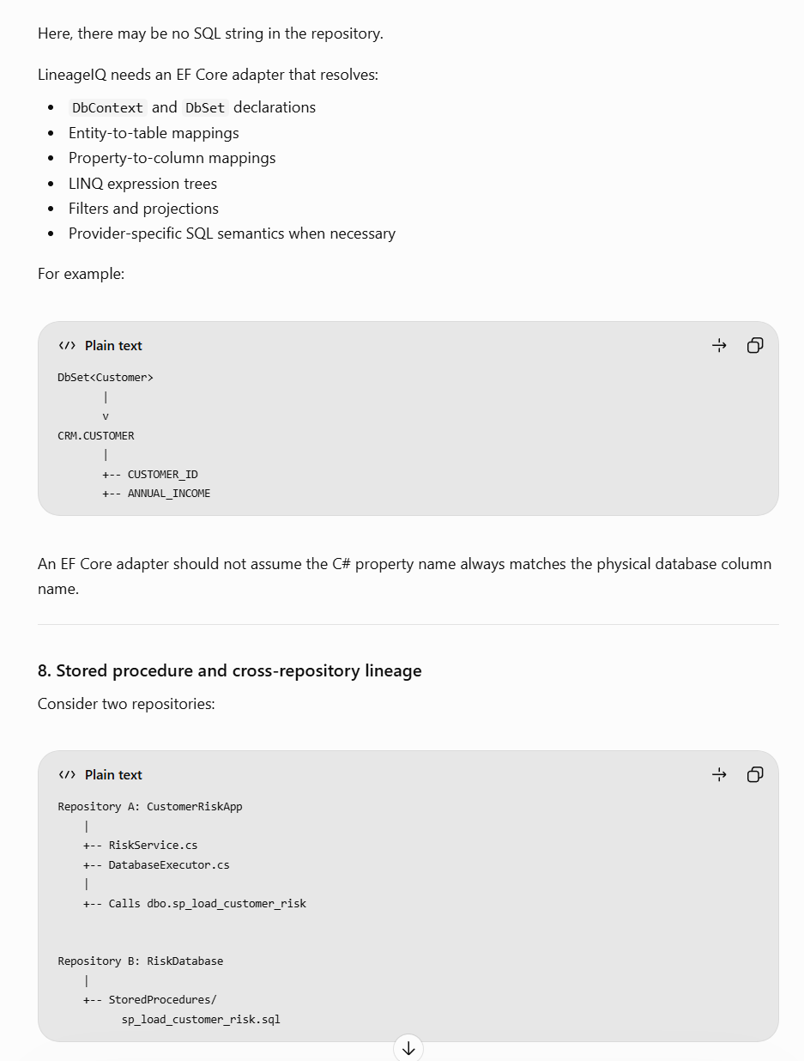

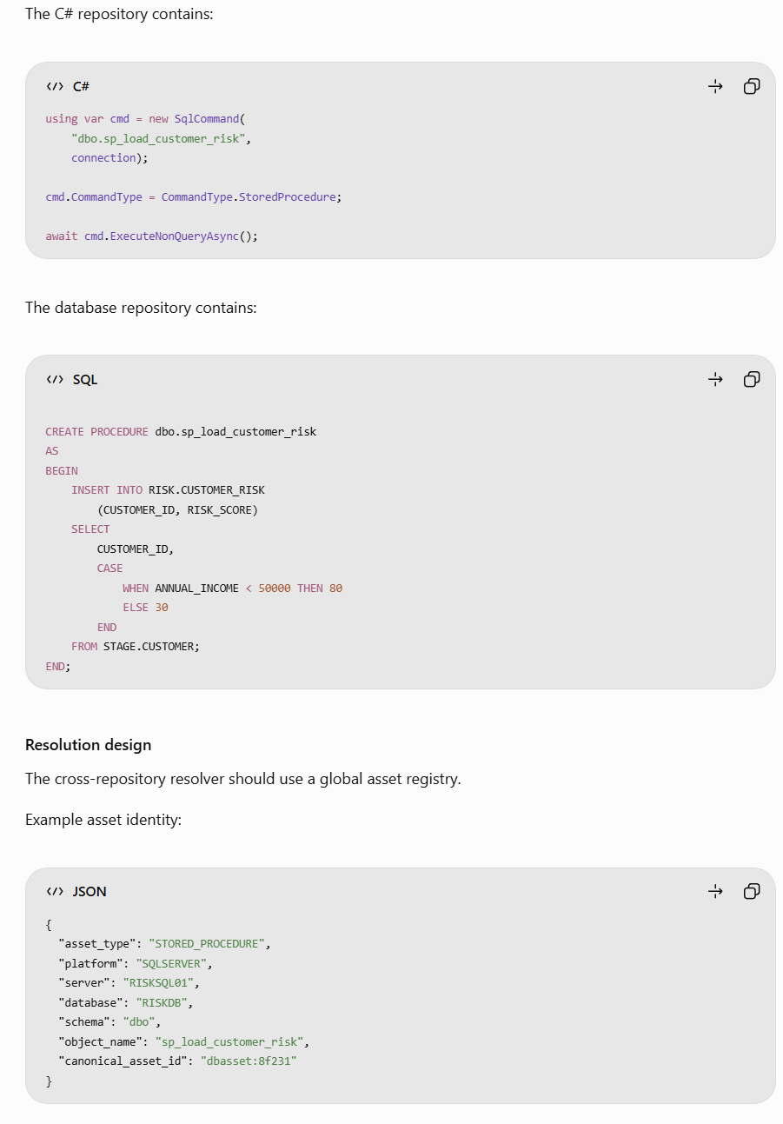

A stored procedure name by itself is insufficient because multiple servers or databases can contain procedures with identical names.
The resolver must consider:
- Connection-string identity
- Database and default schema
- Procedure name and parameters
- Deployment mappings
- Environment and version
- Available stored procedure definitions
Resolution rule: Link a C# invocation to a stored procedure definition only when the database context and object identity are sufficiently established.
If two candidate definitions remain, preserve an ambiguous reference rather than selecting one arbitrarily.
9. LineageIQ canonical model design
I recommend four logical object categories.
9.1 Assets
Represent durable objects such as applications, repositories, files, methods, SQL statements, databases, tables, and columns.
9.2 Relationships
Represent dependencies such as CALLS, EXECUTES_SQL, READS_FROM, WRITES_TO, and DERIVES_FROM.
9.3 Evidence
Represent the facts supporting each relationship, including parser rules, AST references, source locations, and commit identifiers.
9.4 Resolution records
Represent whether a relationship is confirmed, partial, ambiguous, or unresolved.
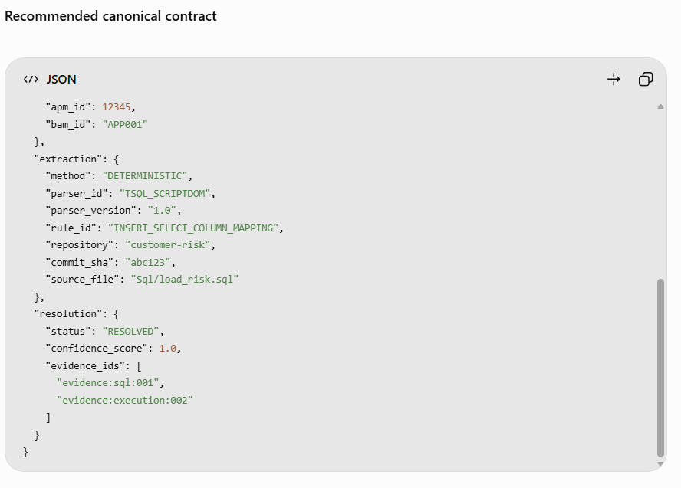

The IDs and business identifiers are illustrative.
For production, global node_id values should include enough platform, environment, and object context to avoid collisions. Use stable asset identities separately from version-specific observations.
A confidence score of 1.0 should be reserved for a well-defined, fully supported resolution policy; it should not imply that static analysis can mathematically guarantee correctness.
Recommended resolution statuses
Status | Meaning
RESOLVED | All required references resolved under the configured analysis assumptions
PARTIAL | Some sources, targets, or bindings remain unresolved
AMBIGUOUS | Multiple plausible candidates
UNRESOLVED | Insufficient evidence to establish the relationship
UNSUPPORTED | Construct is outside parser capability
ERROR | Parsing or analysis failed
Keep resolution_status distinct from confidence_score, evidence_type, and validation_status.

10. Neo4j graph model
For LineageIQ, I recommend storing both physical data lineage and code execution provenance.

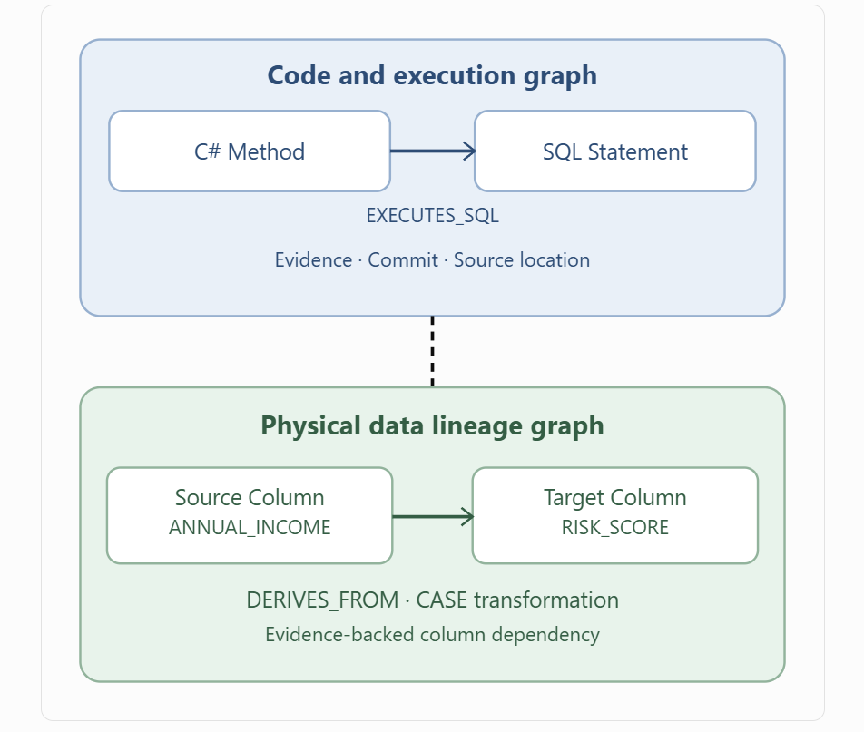
This distinction is critical.
A method calling another method establishes a code dependency. It does not necessarily establish a data lineage edge.
Example Cypher: Upstream column lineage
Assuming DERIVES_FROM is stored from source to target:
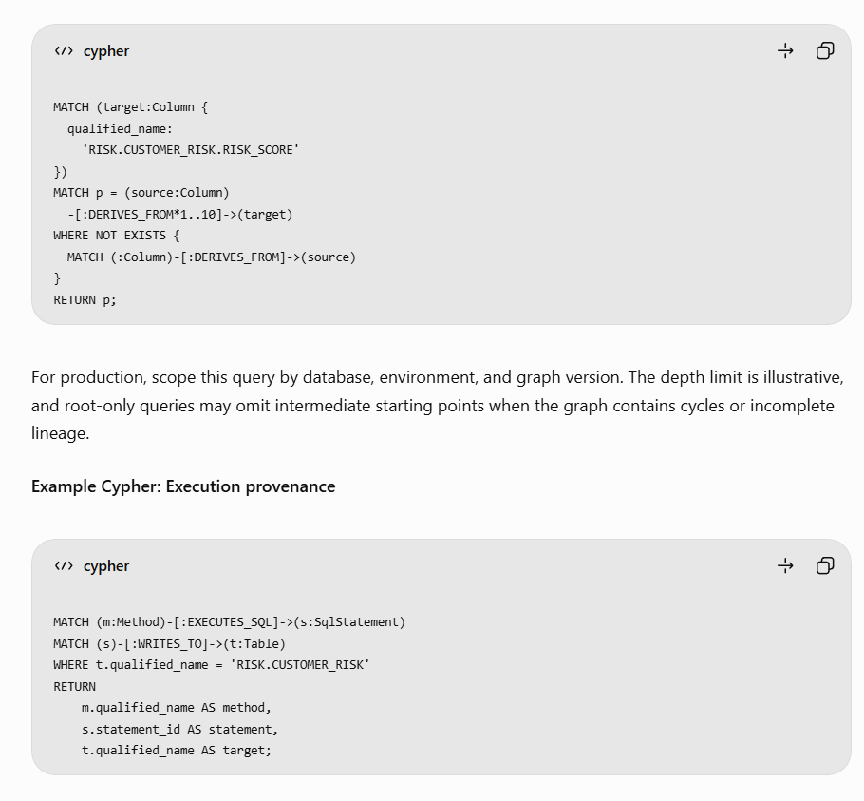
These queries support two different user questions:
- Where does this target column get its data?
- Which application method is responsible for executing the transformation?

11. Data quality extraction
LineageIQ should treat DQ as a first-class capability rather than simply classifying every WHERE predicate as a quality check.
Consider:
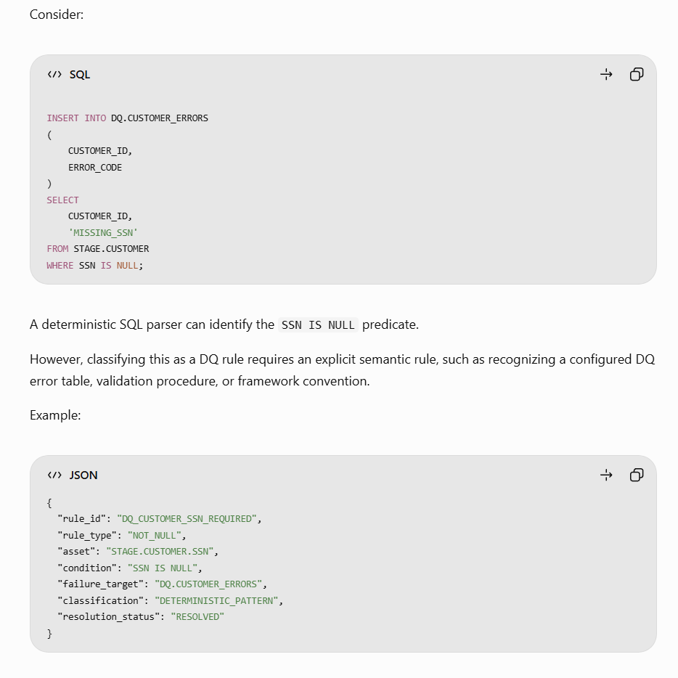
ecommended DQ extraction patterns include:
Category | Example | Detection
Null validation | SSN IS NULL | Predicate + DQ context
Range validation | AMOUNT < 0 | Predicate + validation convention
Referential integrity | Orphan records | Anti-join or configured rule
Duplicate detection | COUNT(*) > 1 | Grouping + rule context
Record count checks | Source vs target count | Aggregate comparison
Exception routing | Insert into error table | Target classification
C# validation | if (!IsValid(...)) | Configured validator adapter
System-level checks, such as row-count reconciliation or batch completion, should be modeled separately from element-level data quality rules.

12. Incremental parsing and dependency invalidation
Reprocessing an entire enterprise repository for every commit will be expensive.
LineageIQ should support content-addressed caching and dependency-aware invalidation.
Recommended process

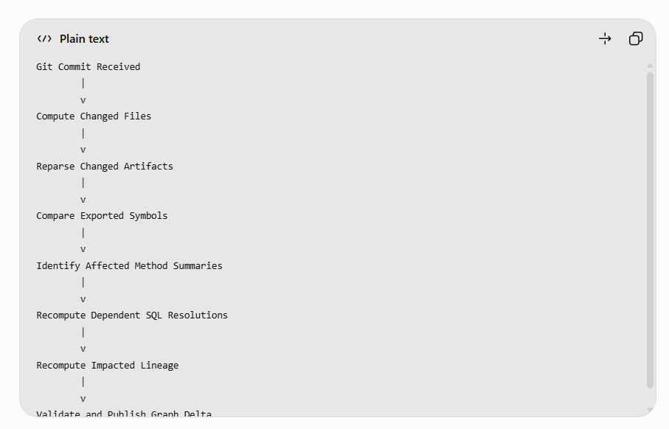

A dependency index might contain:
Artifact | Depends on
RiskService.LoadRiskAsync | SqlFileLoader.Load
SqlFileLoader.Load | Sql/load_risk.sql
DatabaseExecutor.ExecuteAsync | ADO.NET execution adapter
load_risk.sql | STAGE.CUSTOMER schema
Column mappings | SQL AST and schema metadata
If load_risk.sql changes, the system should invalidate the affected SQL AST, method-specific SQL binding, transformation mappings, and graph edges.
If only an unrelated UI file changes, existing lineage results should remain reusable.
Parser-version changes, schema changes, connection mappings, and rule-policy changes can also require invalidation even when Git files have not changed.

13. Error handling, observability, and security
Error handling
The system should never silently omit unsupported or unresolved constructs.
For each repository scan, report:
- Successfully parsed files
- Failed files
- Unsupported syntax
- Unresolved method calls
- Dynamic SQL references
- Missing database metadata
- Ambiguous object references
- Incomplete lineage paths
Operational telemetry
Track parser execution duration, memory consumption, cache-hit rates, method-summary reuse, SQL resolution rates, graph publishing latency, and lineage validation failures.
Security controls
Repository source code is potentially sensitive and should be processed as untrusted input.
Use isolated parser workers, read-only repository access, no arbitrary application execution, restricted outbound networking, resource limits, and controlled access to source snippets.
Do not require production database credentials for basic static analysis. If metadata or runtime traces are used, grant narrowly scoped read permissions.
Connection strings and secrets must be redacted or represented by opaque references in the canonical model.

14. Deterministic validation strategy
I recommend creating a golden lineage test suite containing small, independently verifiable repositories.
Test case | Expected result
Static SQL INSERT SELECT | Correct source/target column mappings
Embedded SQL in C# | SQL linked to executing method
SQL read from file | File resolved and linked to execution
Constant concatenation | SQL reconstructed
SQL passed through 3 methods | Execution path resolved
Dynamic runtime table | Partial/unresolved status
Stored procedure invocation | Procedure linked when identity established
Cross-repository procedure | Correct global asset matching
EF Core property mapping | Physical table/column mapping
SELECT * without schema | Deferred column resolution
Unreachable SQL string | No confirmed execution edge
Duplicate object names | Ambiguous resolution
Failed parse | Explicit error record
Measure at least:
- Precision: Correct reported lineage edges divided by all reported edges.
- Recall: Correct reported edges divided by all expected edges in the test set.
- Resolution coverage: Successfully resolved cases divided by all in-scope cases.
- Unsupported rate: Unsupported cases divided by analyzed cases.
- Provenance completeness: Edges with valid supporting evidence divided by all published edges.
For a regulated financial-services use case, prioritize precision and auditability over maximizing the number of inferred edges.

15. Key architecture decisions
Decision | Recommendation | Rationale
Parser architecture | Language-specific adapters | Avoid one parser trying to understand every language
C# parsing | Roslyn semantic model | Compiler-aware symbol resolution
SQL parsing | Dialect-specific AST | Correct database syntax and transformations
Parser output | Shared IR | Decouple parsing from lineage
Cross-method analysis | Bounded symbolic analysis | Deterministic and scalable
SQL execution detection | Symbol-based sink registry | Avoid unreliable string matching
Dynamic SQL | Partial symbolic representation | Prevent fabricated lineage
Cross-repository linking | Global asset registry | Support enterprise-wide lineage
Canonical graph | Assets + relationships + evidence | Auditability and extensibility
Graph storage | Neo4j | Relationship traversal and impact analysis
Execution platform | Cloud Run Jobs | Isolated, scalable batch processing
Incremental updates | Dependency-based invalidation | Reduce repeated processing
16. Final architectural recommendation
For LineageIQ, I recommend implementing three independently deployable logical engines:
Parser Engine
What exists?
Resolution Engine
How is it connected?
Lineage Engine
Where does data flow?
The most valuable investment is the cross-language resolution engine. Roslyn and ScriptDom already provide robust parsing foundations, but neither independently solves end-to-end lineage across SQL files, .NET methods, database wrappers, stored procedures, and multiple repositories.
By making the resolution engine language-neutral, LineageIQ can eventually integrate Java, Python, Ab Initio, Informatica, Autosys, and other enterprise technologies without rebuilding the core lineage architecture.
The result is an explainable, extensible, and auditable deterministic lineage platform, with no AI dependency in its core parsing and resolution workflow.

